ECOMMERCE DATABASE QUERIES AND SCHEMA

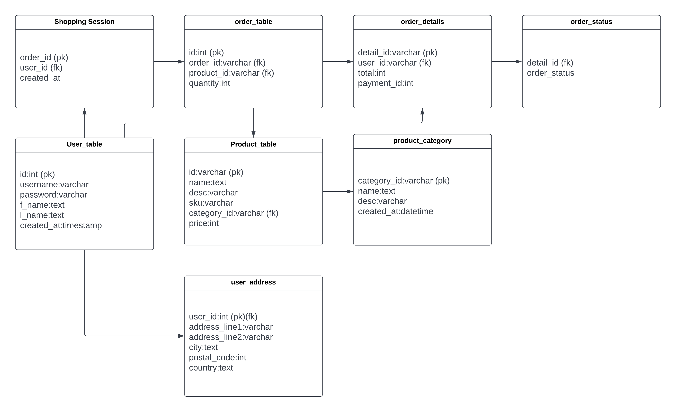

INSERTING TOTAL SUM OF ORDERS IN TABLE ORDER_DETAILS USING SUB QUERY:

INSERT INTO `order_details` (`detail_id`, `user_id`, `total`, `payment_id`) VALUES ('aa130', '1003', ( SELECT SUM(t1.price*t2.quantity) from product t1 JOIN orders t2 on t1.id=t2.product_id JOIN shopping_session t3 on t2.order_id=t3.order_id where t3.user_id=1003 ), '100340');

QUESTIONS

Question: Print the order details with product name , price, quantity and their total price of the user with username = “yatin123”

Answer:

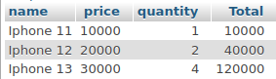
SELECT t4.name,t4.price,t3.quantity,t3.quantity*t4.price as "Total" FROM user t1 JOIN shopping_session t2 on t1.id=t2.user_id JOIN orders t3 on t3.order_id=t2.order_id JOIN product t4 on t3.product_id=t4.id WHERE t1.username="yatin123";

-----------------------------------------------------------------------------------------------------------------------

Question: Get the quantity of product “iphone 11” placed by username “sak9911”

Answer:

SELECT t1.username,t4.name,t3.quantity,t3.quantity*t4.price as "Total Price" FROM user t1 JOIN shopping_session t2 on t1.id=t2.user_id JOIN orders t3 on t3.order_id=t2.order_id JOIN product t4 on t3.product_id=t4.id WHERE t1.username="sak9911" and t4.name="iphone 11" ;
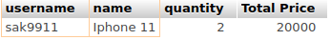

-----------------------------------------------------------------------------------------------------------------------

Question: get details of user who have more than 3 items in a single order.

Answer:

SELECT distinct( t1.username),t1.f_name,t1.l_name FROM user t1 left JOIN shopping_session t2 on t1.id=t2.user_id JOIN orders t3 on t3.order_id=t2.order_id WHERE (SELECT COUNT(t3.id) from orders t3 where t3.order_id=t2.order_id)>2;

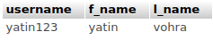

if order quantity changed from 2 to 0

SELECT distinct( t1.username),t1.f_name,t1.l_name FROM user t1 left JOIN shopping_session t2 on t1.id=t2.user_id JOIN orders t3 on t3.order_id=t2.order_id WHERE (SELECT COUNT(t3.id) from orders t3 where t3.order_id=t2.order_id)>0
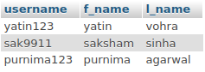

--------------------------------------------------------------------------------------------------------------------

Question: Fetch the order details whose status is “out for delivery”

Answer:

select t1.address_line1,t1.city,t1.postal_code,t2.f_name,t2.l_name,t3.detail_id,t4.order_status from user_address t1 join user t2 on t1.user_id=t2.id join order_details t3 on t2.id=t3.user_id join order_status t4 on t4.detail_id=t3.detail_id where t4.order_status="out for delivery"

-----------------------------------------------------------------------------------------------------------------------

Question: Fetch all the “iphone 13” orders placed ON 2022-07-13

Answer:

SELECT t1.username,t1.f_name,t1.l_name,t4.name,t3.quantity from user t1 JOIN shopping_session t2 ON t1.id=t2.user_id JOIN orders t3 on t3.order_id=t2.order_id join product t4 on t3.product_id=t4.id where t4.name = "Iphone 11" and t2.created_at > '2022-07-13 00:00:00' and t2.created_at < '2022-07-13 23:59:59'

